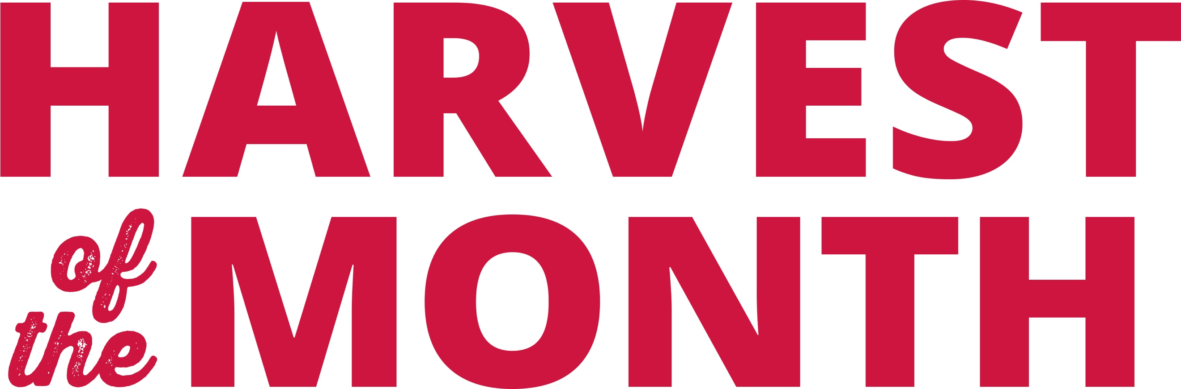

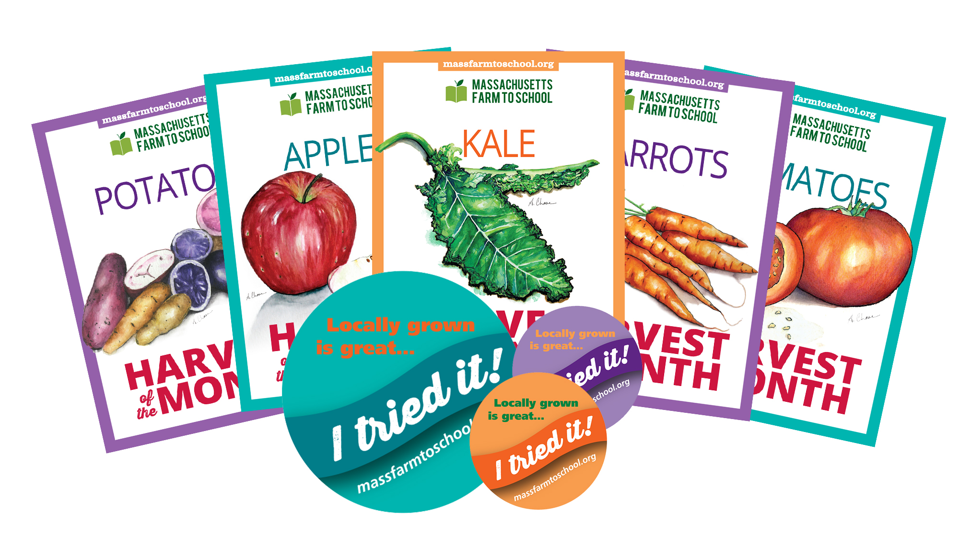

Would you like to introduce your students to Harvest of the Month?

A new classroom opportunity is being offered at [Your School District]. Harvest of the Month will introduce your students to a new, local food item every month based on the growing season in Massachusetts. We will also be sampling the item in our cafeterias on special sample days. On the [day of the month/week] participants will receive a box delivered to [location, ie. Teacher mailbox] to share with their class!

Each box will contain [adjust/adapt/change as needed]:

* A product sample (ie. Pint of strawberries, bunch of carrots, 2 butternut squash)
* A note with the farm where the product was purchased from (farm name/location/any other fact or info about the farm)
* Trading Cards
* Stickers
* An educational flyer about the Harvest of the Month product (fun facts, recipes, etc)
* A classroom activity sheet

To sign up, please visit [add signup.com website, or other registration website]. You will only need to sign up once to receive the Harvest of the Month box all year long. If you wish to cancel your delivery or have any questions regarding this program please contact [YOUR CONTACT INFORMATION].