**March 2021**

**Your School Name/Logo**

|  |  |  |  |  |
| --- | --- | --- | --- | --- |
| Monday | Tuesday | Wednesday | Thursday | Friday |
| 1  Write Here | X  Write Here | X  Write Here | X  Write Here | X  Write Here |
| X  Write Here | X  Write Here | X  Write Here | X  Write Here | X  Write Here |
| X  Write Here | X  Write Here | X  Write Here | X  Write Here | X  Write Here |
| X  Write Here | X  Write Here | X  Write Here | X  Write Here | X  Write Here |
| X  Write Here |  |  |  |  |

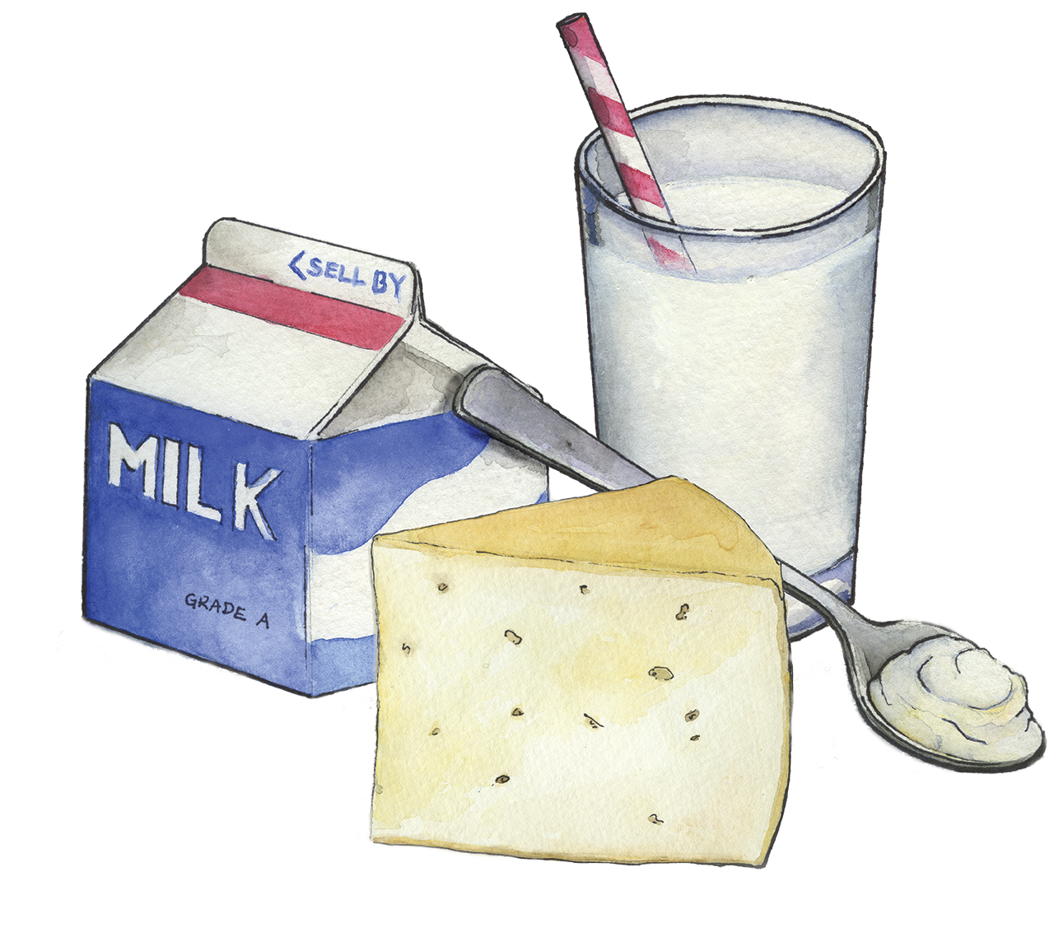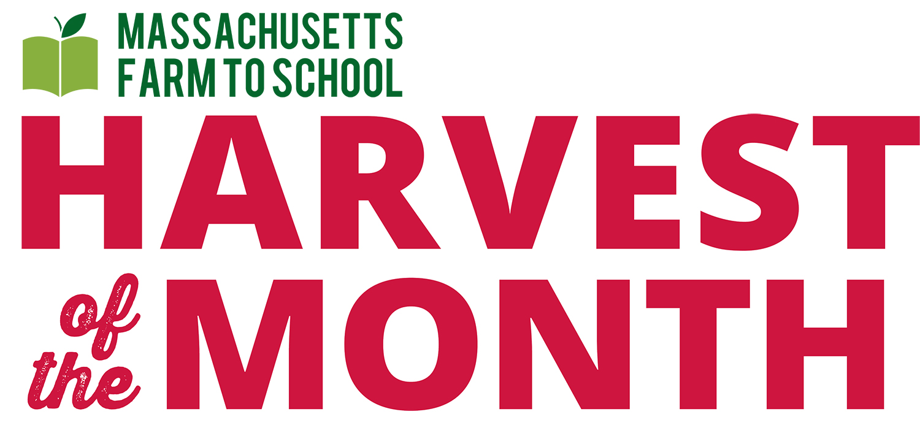

[Use this space to add any additional information about your school meal program.]

**Dairy** is March’s Harvest of the Month. Our [insert recipe name] features dairy from [insert Farm Name, City/Town], only [insert number] miles from [insert school or district name].

*To learn more about Massachusetts Harvest of the Month visit:*

*www.massfarmtoschool.org/hotm*